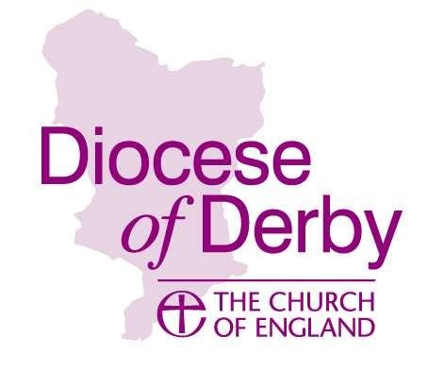
DERBY DIOCESAN BOARD OF FINANCE
Building Community Fund
APPLICATION FORM

1) Name of church & parish, or name of BMO
2) Project title and short description | No more than 50 words
3) Project partners involved and / or community engagement carried out
4) What amount of grant are you requesting? (Maximum £2k) | £
5) What is the total estimated cost of your project? | £
6) What capital assets do you have?
Please state amounts held in bank deposits, investments, etc. Attach recent parish accounts balance sheet/statement of assets

7) If successful in your application when do you anticipate the grant being taken up?
8) Tell us about your project / initiative, including how you aim to meet at least two of the fund’s key outcomes. | No more than 500 words
9) Estimates and allocation of project costs | ITEM Building Community Other Funding  £ £  £ £  £ £  £ £  £ £  £ £  £ £  TOTALS £ £
Name and contact details of project lead | Name:  Role:  Email:  Mobile:
Sponsoring incumbent or Archdeacon | Signed:
Bank Account holding fund | Name:  Sort Code:  Account Number:
Date | / /

Checked by Discipleship, Mission & Ministry Team | Signed:
Date | / /
Grant approved by Business Committee | Signed:
Date | / /

Applications will be considered on a rolling basis at the monthly Business Committee meetings.
Deadlines for submission can be found on the Diocese of Derby website – go to ‘Resources’ and select ‘Fundraising’ or simply search for ‘Building Community’ using the search facility on the Home Page.
FUND INFORNATION & CRITERIA
As the new Diocesan Vision takes shape there will be many ideas bubbling to the surface, that have been inspired or rekindled through this process.
Whilst faithful people are at the heart of building community, sometimes additional resource is required, and this is what the ‘Building Community’ Fund is all about.
Building community is often a work of partnership, be that within the confines of the church or through mission beyond the four walls. It can come about through a simple interaction between two people or a full-blown plan involving a number of partners.
The focus of your application should be on revenue and project costs. If your project requires a significant capital element to augment your building, these costs should be met through another fund such as the Raymond Ross Small or Large Grant Scheme.

Who can apply for funding?
Those involved in time-honoured forms of church or those exploring fresh expressions of church or pioneering new ministries can make an application to the Building Community Fund.

Things to consider before applying:
- The project or initiative must be able to demonstrate substantive engagement with your wider community.
- The maximum amount available is £2,000 with any significant underspend to be recovered by the Diocesan Board of Finance.
- The grant must be spent within 12 months of receiving an award letter.
- If you are working in the context of a parish you will need to gain the endorsement of the incumbent, or during an interregnum, the relevant Archdeacon.
- If you are a Pioneer, you will need to seek the endorsement of the relevant Archdeacon.
- No match funding is required, but the amount requested should account for no less than 25% of the overall project costs.
- If you have access to PCC funds you will need to demonstrate that any unrestricted reserves are spoken for.
- Retrospective funding will not be considered i.e., you must not have started your project or initiative before receiving an award.

How to apply to the Building Community Fund
- Carefully read the grant information and criteria.
- Present your case in no more than 500 words, including a description of what you want to do and how you aim to meet the project outcome criteria.
- Breakdown the project costs showing which will be covered by the fund (see eligible costs) using the table in the application pack.
- Email your application to ‘gareth.greenwood@derby.anglican.org’ clearly titled ‘Building Community Fund Application’.
- Additional documents required include PCC accounts (except for applications from a Pioneer) and a letter/email of support from either Incumbent, or Archdeacon if you are operating under a BMO.

Eligible costs may include, but are not limited to:
- volunteer expenses related to delivery of your project or initiative.
- training costs related to delivery of your project or initiative.
- virtual or in-person event/exhibition costs
- new staff posts related to delivery of your project or initiative.
- digitisation costs
- research costs
- producing resources such as education packs, exhibitions, pamphlets etc.
- other project consumables
- small capital items e.g., a coffee machine, storage boxes, portable p.a. etc.
- equipment or space hire
- costs of temporary permissions and other licensing

The ‘Building Communities’ Fund will not cover costs, including:
- existing staff posts or organisational costs (including continuation funding for existing projects)
- recoverable VAT
- any purchases or activity that has taken place before the grant has been awarded.
- Direct financial support for individuals
- Capital building work.

Key Outcomes
You must demonstrate how your project aims to enable at least 2 of the 4 key outcomes:
- Building stronger links with others in your community.
- Working in partnership; charitable, ecumenical, educational, or civic etc.
- Creating networks for the common good.
- Caring for marginalised and vulnerable sections of your community.
Projects that have an emphasis on inclusivity, and aim for positive social, environmental, economic, and just outcomes, will be of particular interest.

Other conditions of the grant

- Produce a short project report showing how the money was spent and what impact the project had (or continues to have).
- Reimburse the Building Community Fund with any unspent grant.

If you require further help or guidance as to making a successful application, you should contact Gareth Greenwood on 01332 388690 (Mondays/Tuesdays) or email ‘gareth.greenwood@derby.anglican.org’

