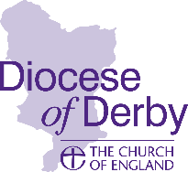
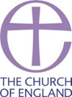
Synodical Government Measure 1969
CHURCH ELECTORAL ROLL CERTIFICATE

Parish of

in the deanery of and the Diocese of Derby.

I hereby certify that the number of names entered upon the Church Electoral Roll of the above parish, as revised in preparation for the Annual Parochial Church Meeting held in the year 2020, was

Date ............................. Signed.................................
Full Name..................................................................
Chair / Vice-Chair / Secretary / Electoral Roll Officer (delete as appropriate)

Notes:
1. This certificate is to be signed by the chair, vice-chair, secretary or church electoral roll officer of the parochial church council.
2. Not later than 2 August 2021, one copy of the completed certificate should be sent by post to your diocesan office for the attention of the Diocesan Secretary (Derby Church House, Full Street, Derby, DE1 3DR)
3. A copy of this certificate must also be affixed, for a period of not less than 14 days, on or near the principal door of every church and building licensed for public worship in the parish.

