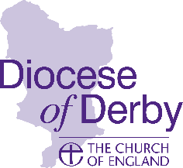

Synod Elections article
for newsletters / parish newsletters
Notes to editor:
Before including the text, please complete the relevant details of the Deanery Administrator including their email address. This article is 198 words in length.
If you wish to include a photo of Will Hagger, Diocesan Secretary, please email communications@derby.anglican.org who can provide this.

A message from Will Hagger, Diocesan Secretary
Could YOU make a difference
to the Church of England in Derbyshire?
Diocesan Synod is an important part of our planning and decision-making process.
We are looking for representatives to help shape diocesan priorities for the next
three years and beyond, consider how we deploy our people and financial resources, develop our environmental goals, and debate our response to the issues facing the Church of England locally and nationally.
Diocesan Synod nominations are now open and parish worshippers (lay) who meet the following basic criteria are eligible to stand:
- Over the age of 16.
- On the electoral roll of your parish.
- Available to participate in three meetings a year (expenses will be paid).
A range of theological perspectives is encouraged. In addition, we particularly encourage nominations from representatives who will support our strategic ambition to grow younger and more diverse and from those who are currently underrepresented on Diocesan Synod:
- UK Minority Ethnic/Global Majority Heritage (UKME/GMH) members.
- Youth representatives.
- Those living with physical, mental, and neurodivergent challenges.
- LGBTQI+ representatives.
Make a difference. Be the change.
For more details visit www.derby.anglican.org/synod.
Nomination forms are available from elections@derby.anglican.org or by contacting your Deanery Administrator, <Deanery Administrator name> by email to <Deanery Administrator email address (ending in @derby.anglican.org)>.

