**ROLE DESCRIPTION**

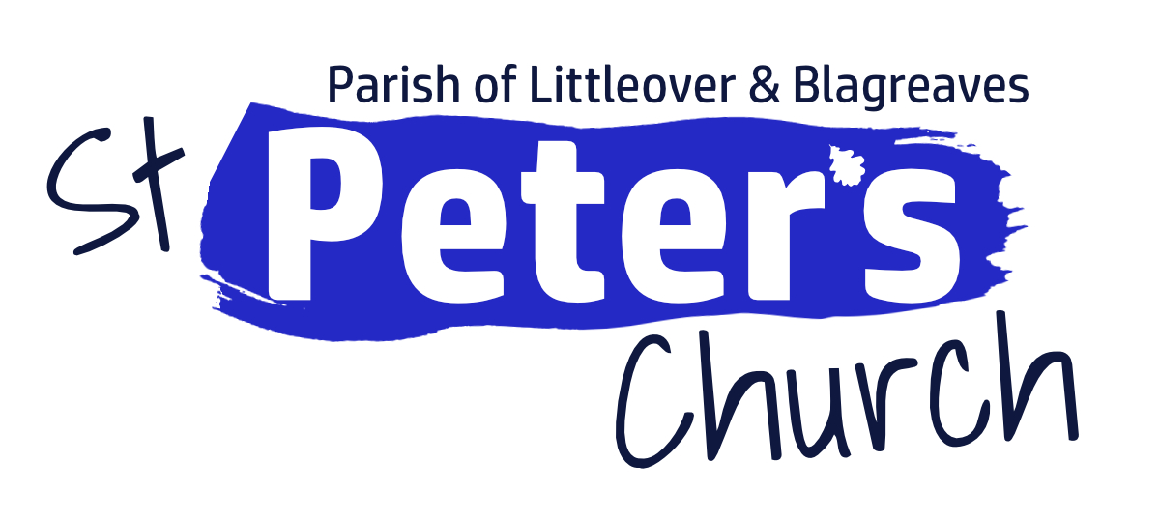

**Anna Chaplain**

**St Peter’s Church Littleover & Blagreaves**

**Hours:** 20 hours/week

**Contract**: three-year contract renewable for a further two years.

**Salary**: £15,000 pa with NI and pension contributions paid

**Background to Role**

There are currently 440+ Anna Chaplains (and others in equivalent roles) in the national network ministering amongst older people across the UK, as of July 2025. Named after the widow Anna in Luke's gospel, the purpose of Anna Chaplaincy is to nurture, support and develop the spiritual life of older people.

The Anna Chaplain aims to offer spiritual support to older people living within parish of Littleover & Blagreaves, will be a practicing Christian and in a church affiliated to the Council of Churches in England and Wales.

**About the Parish**

St Peter’s Littleover and Blagreaves is a large parish in the south west of the City of Derby. With a population of over 28,000 and nearly a fifth of them over the age of 65 and over a quarter of those older people live alone. There are plenty of nursing and residential homes as well as sheltered housing complexes and while we have good relationships with some, we are unable to reach everyone.

St Peter’s Church is low evangelical in church style, inclusive in language and outlook with an incumbent, part time associate and currently two curates, plus three readers. Usual Sunday Attendance is between 80-95 and the midweek communion has approx. 30-35 regular attenders.

Please go to [www.stpeterlittleover.org.uk](http://www.stpeterlittleover.org.uk) for more information.

**Principles of the Role**

The Anna Chaplain will focus on the spiritual needs and priorities of older people focusing upon the whole person and their wellbeing and seeking to accompany individuals wherever they are at in their spiritual journey.

Where appropriate, the Anna Chaplain will be a person through whom the voice of older people, their concerns and their gifts (both as individuals and as a group) will be heard/received both in the church and the wider community. Where older people experience isolation, separation and loneliness, the Anna Chaplain will seek to build a bridge of relationship with other agencies, back into engagement, potentially with both the church and the wider community.

**General Overview**

* To enable and encourage pastoral support, encouragement in faith and advocacy for the needs of people who are 65 and over in our church and community
* To offer, to those of 65 years and over, opportunities for prayer and discipleship and exploring faith in sensitive and appropriate ways, helping them to grow in spiritual maturity, in love and knowledge of God and an assurance of his unconditional and inexhaustible love for them
* To support the families of those who are 65 and over in their care and understanding of their elderly relative and the spiritual issues that they may face
* To be fully trained in Church of England safeguarding requirements and confidentiality, reporting any concerns appropriately.

**Within the life of the church**

* Be part of the staff team, meeting weekly
* Supporting St Peter’s existing ministries to older people
  + Visiting nursing and residential homes providing services and chaplaincy support
  + The pastoral work of Lunch Club and Crossed Keys Café
  + Part of the team offering the bi-monthly Dementia service
  + Pastoral visiting to congregation members isolated at home.
* Be involved in midweek and Sunday services, attentive to the needs of the older members of our congregation.

**Within the wider Parish**

* Building on the support to local nursing and residential homes, including sheltered housing schemes where appropriate
* To seek to develop new opportunities for ministry among those of 65 years and over, where appropriate in partnership with other churches and community organisations.

**New opportunities**

* To develop, oversee, support and work alongside a small team of volunteer Anna Friends to assist in carrying out the Anna Chaplaincy ministry
* To create opportunities for evangelism with those over 65, rediscovering faith from younger years, or encountering Jesus for the first time
* To offer assistance with end-of-life conversations, funeral arrangements and bereavement support
* To encourage engagement with, and provide information concerning, ministry to the 65 and over age group in the PCC, wider church and community.
* To develop links and working relationships with community leaders and key stakeholders working with those who are 65 and over, for example care homes, charitable and community organisations and council-led partnership groups.
* To develop self-sustaining long-term ministry to the 65 and over age group that can be maintained beyond the life of the post-holder’s contract.

**Other duties and responsibilities**

* Maintain up-to-date information of existing activities, groups and support available in your local church and the wider community, including any relevant statistics
* Maintain written records of work undertaken, ensuring confidential records are kept securely in accordance with Data Protection law
* Meet regularly with the line manager, and follow agreed reporting structures
* Access relevant training offered through BRF’s national team
* Keep records of any monies, receipts and out-of-pocket reimbursements, as required by the PCC.

**Key Relationships**

* Responsible to line manager Reverend Alicia Dring
* Supported by pastoral supervision in some form e.g. mentor, spiritual director
* Working relationships within the church and local community:
  + ordained and lay leaders in St Peter’s Church
  + individual older people and family members
  + related local agencies
  + care home staff.
* Connecting with the BRF national Anna Chaplaincy network

**Responsible for:** recruiting, training, managing and overseeing the Anna Friends

**Contract**

* The initial contract is for three years, with the option to extend to five in total
* Working hours – 20 per week
* Renumeration £15,000 pa
* There is no housing allowance with this post
* Successful applicants will be expected to work from home and there is a ‘hot desk’ available in the church office
* Working agreement to be compiled following appointment
* Holidays 28 days pa plus Bank Holidays
* It is an occupational requirement for the person appointed to be a professing and practising Christian, lay or ordained, in a church affiliated to the Council of Churches in England and Wales (Equality Act 2010)
* Enhanced DBS and references will be required
* Capability, Grievance and Disciplinary procedures are available on request.

**How to apply**

* Please apply in writing with a CV, two referees (one professional, one personal), and a covering letter
* Address to: [alicia@stpeterlittleover.org.uk](mailto:alicia@stpeterlittleover.org.uk) or

Alicia Dring, Littleover Vicarage, 35 Church Street, Littleover, Derby DE23 6GF

* Closing date 14 November 2025
* If you have any queries relating to the post please call Alicia on 01332 767802.