Ministerial Development Review, Diocese of Derby

Form 4. Interim Review Summary

Thank you for your prayerful input into this MDR. This form should be completed by the reviewer, with the reviewee, at the end of the full review meeting. Once the form is submitted, a copy will be shared with you. If you are completing this form in Word rather than online, then this should be returned by your reviewer at the end of your review to the Bishop of Derby using the email address MDR@bishopofderby.org. Please ensure that your reviewer copies you in to this email.
How we will use this form
The responses given in this form will be kept on your blue file. The form is administered by the Bishop's representative (Chaplain). Your learning, and development goals will be shared with your Archdeacon who is available to offer ongoing developmental support should you request this. They are also shared with relevant DBF colleagues to inform future learning and development provision within the diocese, for e.g. the Ordained Ministries Development Officer and the Director of People and Ministry.
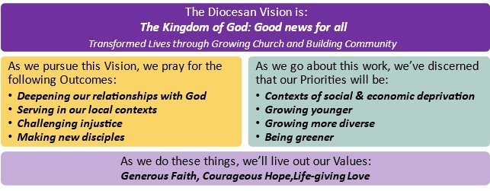

Review Information
Name of Reviewee
Name of Reviewer
Date of Review
Appointment/Post
Deanery and Archdeaconry
Reviewee's Email Address
Reviewer's Email Address

Interim Review Summary
Priority 1 - Mission and Ministry
What was your first chosen priority?

Does this priority still feel relevant, or does it need amending in any way?

What progress has been made towards meeting this priority?

What further work is needed towards priority 1 in the next 12 months?

Is there any additional learning or support that would help you deliver this priority?
For Continuing Ministerial Development, visit the website here: https://derby.anglican.org/en/church-admin/continuing-ministerial-development.html.
The website outlines the training opportunities available throughout the year.

Priority 2 - Mission and Ministry
What was your second chosen priority?

Does this priority still feel relevant, or does it need amending in any way?

What progress has been made towards meeting this priority?

What further work is needed towards priority 2 in the next 12 months?

Is there any additional learning or support that would help you deliver this priority?
For Continuing Ministerial Development, visit the website here: https://derby.anglican.org/en/church-admin/continuing-ministerial-development.html. The website outlines the training opportunities available throughout the year.

Priority 3 - Mission and Ministry
What was your third chosen priority?

Does this priority still feel relevant, or does it need amending in any way?

What progress has been made towards meeting this priority?

What further work is needed towards priority 3 in the next 12 months?

Is there any additional learning or support that would help you deliver this priority?
For Continuing Ministerial Development, visit the website here: https://derby.anglican.org/en/church-admin/continuing-ministerial-development.html. The website outlines the training opportunities available throughout the year.

Priority – Your Wellbeing
What do you need to prioritise in relation to your wellbeing?

What have you done, or what are you planning to do, towards this wellbeing priority?

Is there anything else that it would be helpful to talk about during this conversation? If so, please summarise here.

Form Submission
When both the reviewer and reviewee are happy with the content of the form, they should each add their name and date below to indicate acceptance of this form and the form should be sent by email to the bishops’ office using the email address MDR@bishopofderby.org.

Reviewee’s Name: | Date:
Reviewer’s Name: | Date:

