**CONFIRMATION RETURN**

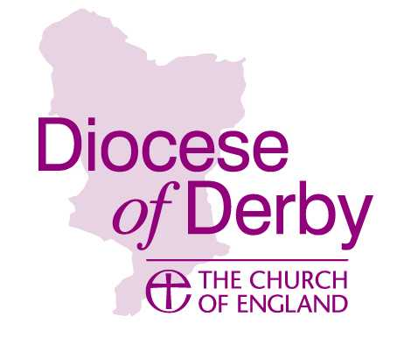

It is important that this form is completed correctly and brought to the service of confirmation so that it can be signed by the confirming bishop and then returned to the Bishop of Derby. We have to complete a yearly return from the Archbishops’ Council of numbers being confirmed in the diocese so it is important that the information is accurate.

**Service held at: On:**

**Candidates from the parish of: Presented by the Revd:**

|  |  |  |  |  |  |
| --- | --- | --- | --- | --- | --- |
|  |  | **Please indicate within which age group the candidates fall** | | | |
| Name (Block capitals please if handwritten) | M/F | Under 12 years | 12-15 years | 16-19 years | 20 and over |
|  |  |  |  |  |  |
|  |  |  |  |  |  |
|  |  |  |  |  |  |
|  |  |  |  |  |  |
|  |  |  |  |  |  |
|  |  |  |  |  |  |
|  |  |  |  |  |  |
|  |  |  |  |  |  |
|  |  |  |  |  |  |
|  |  |  |  |  |  |
|  |  |  |  |  |  |
|  |  |  |  |  |  |

**Total number of females . . . . . Total number of males . . . . . Total number of candidates . . . . .**

**Bishop’s Signature ………………………………………….**