Prayers and Resources for anniversary of NHS: 5 July

The National Health Service came into being on 5 July 1948. During post-war reconstruction, improving the healthcare of the nation was seen as crucial to the nation’s recovery. Beveridge, the architect of the NHS, identified "five giants” that had to be slain: want, disease, squalor, ignorance and idleness. The cataclysm of war provided the stimulus for radical reform. It was a momentous achievement and, in spite of early professional resistance to some of the proposals, it was born of a national consensus: everybody wanted the new service to work.
The NHS was based on principles unlike anything that had gone before. It was financed almost entirely from central taxation. That the rich paid more than the poor for comparable benefits was regarded as a crucial part of the scheme. Everyone was eligible for care, even people temporarily resident or visiting the country. People could be referred to any hospital, local or more distant. Care was free at the point of use, although prescription and dental charges were subsequently introduced.
During the current pandemic, there has been immense national and local support for the NHS and its front line workers. The emergence of the Thursday ‘Clap for Carers’ was a significant experience in the lockdown. Thanksgiving binds communities together, turning ‘I’ into ‘we’. The contribution of carers and key workers who have given of themselves sacrificially needs to be honoured. Sharing stories of people and events during the crisis is likely to form the kernel of any community celebration. Unsung heroes need to be applauded.

+ Robert Exon
Chair of the Liturgical Commission

Mary Seacole and Florence Nightingale
The seven critical-care Covid Hospitals have been named after Florence Nightingale, and a post-Covid rehabilitation facility named after Mary Seacole, both prominent figures in nursing history and role models in the NHS.
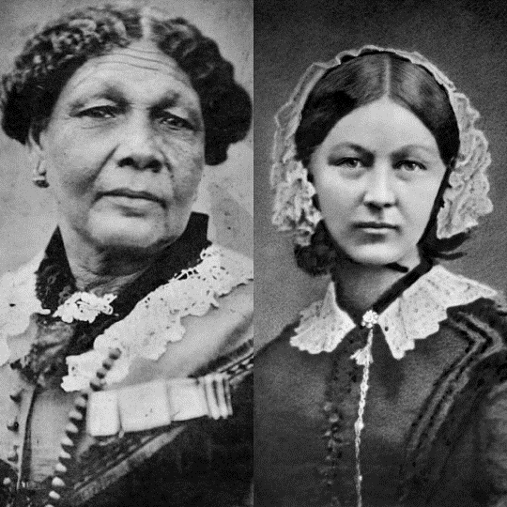
Mary Seacole was a pioneering nurse and heroine of the Crimean War, who as a woman of mixed race is today celebrated as an inspiration for the many BAME people who sustain our NHS. Born Mary Jane Grant in Kingston, Jamaica in 1805 to a Scottish soldier and Jamaican mother, Mary learned her nursing skills from her mother who kept a boarding house for invalid soldiers. She was an inveterate traveller, and before her marriage to Edwin Seacole in 1836 visited other parts of the Caribbean, as well as Central America and Britain. On these trips, she complemented her knowledge of traditional medicine with European medical ideas. In 1854 Mary approached the War Office, asking to be sent as an army nurse to the Crimea. She was refused, but undaunted, funded her own trip to the Crimea where she established the ‘British Hotel’ near Balaclava for sick and convalescent officers. She also visited the battlefield, sometimes under fire, to nurse the wounded, and became known as ‘Mother Seacole’.
Florence Nightingale was born in 1820 into a wealthy family. In the face of their opposition, she insisted that she wished to train in nursing. In 1853, she finally achieved her wish and headed her own private nursing institute in London. Her efforts at improving conditions for the wounded during the Crimean War won her great acclaim and she devoted the rest of her life to reforming nursing care. Her school at St Thomas’s Hospital became significant in helping to elevate nursing into a profession.

RESOURCES

For the NHS
God of healing and compassion,
we thank you for the establishment of the National Health Service,
and for the dedication of all who work in it:
give skill, sympathy and resilience
to all who care for the sick,
and your wisdom to those engaged in medical research.
Strengthen all in their vocation through your Spirit,
that through their work many will be restored to health and strength;
through Jesus Christ our Lord.
Amen.

Everlasting God,
at this time we lift to you
those from all nations and backgrounds
who work on the front line in healthcare.
Give them skill and wisdom in their work.
Be their strength and their shield
as they give of themselves in the care of others.
Amen.

For carers and health professionals
Heavenly Father,
whose blessed Son came not to be served but to serve:
bless all who, following in his steps,
give themselves to the service of others;
that with wisdom, patience, and courage,
they may minister in his name to the suffering and the needy;
for the love of him who laid down his life for us,
your Son our Saviour Jesus Christ,
who lives and reigns with you and the Holy Spirit,
one God, for ever and ever.
Amen.

Lord Jesus, who healed the sick and gave them new life,
be with all carers and health professionals,
as they act as agents of your healing touch.
In desperate times, keep them strong yet loving;
and when their work is done,
be with them in their weariness and in their tears.
Amen. from Norfolk and Norwich University Hospitals Chaplaincy, by Althea Hayton – adapted

Prayers in relation to Covid-19
Keep us, good Lord,
under the shadow of your mercy
in this time of uncertainty and distress.
Sustain and support the anxious and fearful,
and lift up all who are brought low;
that we may rejoice in your comfort
knowing that nothing can separate us from your love
in Christ Jesus our Lord.
Amen.

Lord Jesus Christ,
you taught us to love our neighbour,
and to care for those in need
as if we were caring for you.
In this time of anxiety, give us strength
to comfort the fearful, to tend the sick,
and to assure the isolated
of our love, and your love,
for your name’s sake.
Amen.

Collect for St Luke
Almighty God,
you called Luke the physician, whose praise is in the gospel,
to be an evangelist and physician of the soul: by the grace of the Spirit
and through the wholesome medicine of the gospel,
give your Church the same love and power to heal;
through Jesus Christ your Son our Lord,
who is alive and reigns with you,
in the unity of the Holy Spirit,
one God, now and for ever.
Amen.
Readings
Isaiah 35.3–6 Strengthen the weak hands
Ecclesiasticus 38.1–9 The Lord created medicines out of the earth
Luke 7.1–10 Jesus heals a Centurion’s servant
Romans 12.1–8 The gifts of the Body of Christ
Colossians 3.9–14 Put on compassion and kindness
James 5.13–16 Anointing the sick
Revelation 22.1–5a The tree of life

Responsory
Trust in the Lord with all your heart;
and be not wise in your own sight.
Trust in the Lord with all your heart;
and be not wise in your own sight.
In all your ways acknowledge him
and he will make straight your paths.
Trust in the Lord with all your heart.
Glory to the Father, and to the Son and to the Holy Spirit.
Trust in the Lord with all your heart;
and be not wise in your own sight.

Intercessions
Let us pray to God our Father, whose Son came that we may have life.
We give you thanks for the life and work
of all those whose vision founded our National Health Service,
and for those who serve others in care and compassion.
We pray that their work and ministry to the sick may enrich and support the welfare of all.
Lord, hear us.
Lord, graciously hear us.
We give thanks for all who provide leadership in healthcare,
for those who exercise stewardship and allocate resources
and pray that, in challenging times,
support and compassion may be shown to those most in need.
Lord, hear us.
Lord, graciously hear us.
We pray for all who promote health and wellbeing in policy and practice;
for all who care for the sick, in hospital, in care homes, and at home;
for doctors, nurses, care assistants and cleaners.
We seek guidance and strength for all chaplains,
and for all engaged in teaching and medical research.
Lord, hear us.
Lord, graciously hear us.
We pray for those who suffer in body, mind, or spirit;
for those who are terminally ill, elderly or frail;
for all who live with disability or in constant pain,
and for the many who strive to bring comfort and healing to them.
Lord, hear us.
Lord, graciously hear us.
Remember in your kingdom, O Lord,
all those who have faithfully served you here on earth and are now at rest;
grant us, with them, and with all the faithful departed, the joy of your salvation.
We commend ourselves, and all for whom we pray,
to the mercy and protection of God.
Merciful Father,
accept these prayers
for the sake of your Son,
our Saviour Jesus Christ.
Amen.

Personal Prayers
How generous is your goodness, O God,
how great is your salvation,
how faithful is your love;
help us to trust you in trial
and praise you in deliverance;
through Jesus Christ our Lord.
Amen.

Jesus, our companion,
when we are driven to despair,
help us, through the guidance of your spirit
and through the friends and strangers we encounter in life,
to know you as our refuge, our way, our truth and our life.
Amen.

