MAKE A CHRISTMAS SCENE Sarah Brown: Diocesan Children’s Advisor

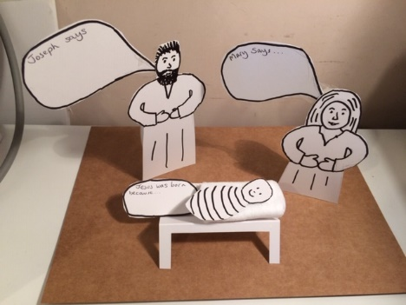
Sparkling Christmas lights and shops full of cards and wrapping paper tell us that 25th December is getting close! But when Jesus was born there were no fancy decorations or fabulous food. His mother settled him down to sleep in an animal food trough, or manger as it is often called.
Here are some instructions to make a Nativity Scene which you could display in your home, or perhaps your church. There’s nothing complicated or expensive needed – you might even have everything you need at home already. The templates and instructions are also on the website at
You will need:
- White card – lots of cereal packets are white inside if you open them up carefully or hunt around for card from packages, calendars etc. Check no-one needs it!
- Kitchen or toilet roll tubes
- Scissors (ask an adult to help)
- Black felt pen
- Pencil
- Sticky tape or glue
Optional:
- Felt pens or colouring pencils, scraps of coloured paper and glue if you’d like to decorate your Nativity scene
What to do:
- EITHER; cut out the templates (Mary, Joseph, Jesus, manger and speech bubbles) and use a pencil to draw around them on your white card (check that no-one is still reading the magazine) OR, print out the figures from the internet, cut these out and use in the same way.
- Go over your pencil lines with a black felt pen, and add other features using your imagination or copying the templates.
- Cut out your figures and the speech bubbles
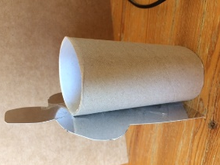
- Write or draw in the speech bubbles. What do you think Mary and Joseph would have said when Jesus was born? You could write on one for Jesus too – maybe you could write WHY you think Jesus came to us as a baby.
- Use a toilet roll tube to make Mary and Joseph stand up. Stick the tube to the back of the figure.
- Cut out the crib and fold it as shown. You could put some fabric or cotton wool in the crib for the baby to lie on.
Now it’s over to you! You could colour or decorate your Nativity Scene or add some of the other people who visited Jesus, shepherds or wise men. Maybe you’d like to find a box to decorate as a stable and put your figures in it – be as creative as you like!
Do send a photo of your completed Nativity Scene to: Sarah.brown@derby.anglican.org and we’ll aim to display these.
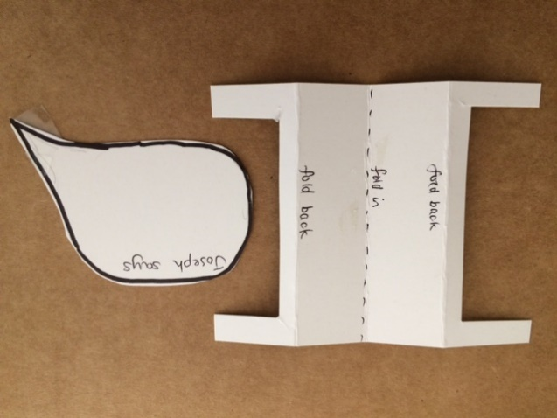
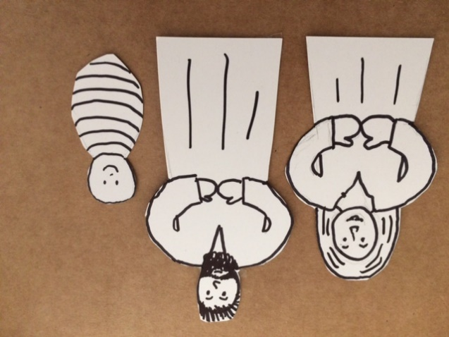
Use the Mary outline also for the angel. Use the Joseph outline for shepherds and kings too. Turn the baby sideways, add legs and ears to be a sheep!

