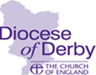
SAFEGUARDING NEWSLETTER

Introduction

In this issue:

Introduction

DSAP

Reflection

Training update

Bank Holiday cover

Dates for your diary

Welcome to our winter newsletter. It feels far too late to wish everyone a happy New Year, but we hope that 2022 is going well for you all. This issue includes information about our Diocesan Safeguarding Advisory Panel and the work they do. We reflect on two high profile cases from the press and include our usual updates etc.

In January, we heard the sad news that Sue Gotch has passed away. We are very grateful for the commitment she showed to safeguarding in her role as PSO in Etwall and we send our condolences to all who knew and loved her.
Spotlight …. Diocesan Safeguarding Advisory Panel (DSAP)

The DSAP is a multi-agency forum set up to provide a source of independent advice and expertise on sound safeguarding policies, procedures and practices to the diocesan bishop and other senior clergy and officials. There is one in every Diocese. The Independent Chair of the panel works with senior representatives, including Bishop Libby, the Archdeacons and the Dean, who all have leading roles in promoting safeguarding. The panel also includes senior representatives from the statutory safeguarding agencies such as the police, local authority, probation and health. These agencies are working together every day to protect vulnerable adults and children, bringing real expertise and advice. Parish Safeguarding Officer, Alan Hudson, is a member of the panel and helps us to understand safeguarding work in parishes.

At the panel we talk about work going on at a national level such as the responses to the IICSA Inquiry and local issues such as training, DBS, information sharing and learning. Our aim is to support safeguarding practice to be as good as it can be and to embed a safeguarding culture.

More recently the panel has overseen the development of a new Safeguarding Strategy and was consulted on the Survivor Strategy. Engaging with survivors of abuse is essential and we have been working hard to find appropriate representation at the Panel so that we can understand their experiences and provide appropriate responses.

In the last 12 months the panel has overseen the implementation of the Past Cases Review 2 project (PCR2) which has been reviewing previous cases. This has been a huge undertaking and this important work will help us to understand where the Diocese needs to focus, to improve practice going forwards.

Meet our DSAP independent chair ….

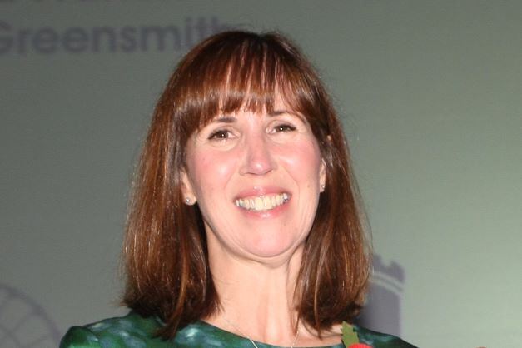
I am Helen Jebb, and I am the independent chair for DSAP. Previously, I worked as a Detective Chief Superintendent in Nottinghamshire Police where I was responsible for investigations, safeguarding, criminal justice and intelligence, working extensively across the region, including Derbyshire. I am also a coach working with people who want to develop their leadership skills and a Co-Chair for Juno Women’s Aid, a charity supporting women and children suffering domestic abuse. I really enjoy working with people from different organisations and believe there is so much we can do together.

I live in Nottinghamshire, and I am married to Mick, we have a daughter Millie who is a keen footballer and golfer. We all love eating out and are really glad to be able to do that again!

If you would like to know any more about DSAP please get in touch with me: DSAP.Chair@derby.anglican.org

Reflection

In December the press reported extensively on the deaths of two young children – Arthur Labinjo-Hughes (who died in June 2020) and Star Hobson (who died in September 2020) – following the convictions of those responsible for their deaths. All agencies involved in such cases seek to learn the lessons about how they worked together and whether any opportunities were missed to protect the child. No doubt the reviews will identify the impact of lockdowns during the pandemic as a complicating factor, reducing the visibility of children who may be at risk.

If nothing else, such cases bring home the fact that these situations do still happen in 21st century Britain and the importance of our safeguarding responsibilities. We remain grateful for your hard work and vigilance, particularly during what has been a difficult two years for us all – thank you.

Training Update

The safeguarding training programme for this term (up until April) continues to be available for booking through the diocesan safeguarding pages: https://derby.anglican.org/en/who-needs-safeguarding-training.html and Eventbrite. There are a number of courses available and those roles for which attendance is required are detailed on the Training Matrix. Courses available are:

Leadership (two sessions on Zoom)
Domestic Abuse Awareness (one session on Zoom)
Safer Recruitment and People Management (one session on Zoom)
Parish Safeguarding Officer Induction / Refresher (one session on Zoom)

Domestic Abuse training is changing from May this year. The Church of England has produced an e-learning Domestic Abuse module, available on the Church of England Safeguarding Training Portal. From May this will be required training for all Clergy, Readers, pastoral workers and all PCC members. We will provide further information in due course. Please note that we will continue to run the current Domestic Abuse Awareness courses over zoom until May. The current priority is to ensure that all PCC members complete the Basic and Foundation modules.

For more information, please check our website safeguarding pages, or email:
Nick.harding@derby.anglican.org - safeguarding training requirements and content
Judie.fogarty@derby.anglican.org – safeguarding training bookings, DBS, and certificates

Thank you for all you do in ensuring that people grow in their understanding of safeguarding through training.

Bank Holiday cover

We have partnered with thirtyone:eight to enable you to access safeguarding advice for bank holiday periods throughout the year (including Christmas and New Year) via their helpline. If you require emergency safeguarding advice over bank holiday weekends, please contact the helpline on 0303 003 1111. Further details can be found here.

Dates for your diary

We are planning to run two PSO events later this year, both with the same content:
25 June – in person – venue to be confirmed
20 September – zoom.
Both events will take place in the morning and further information will follow in a separate email in due course – we look forward to seeing you there!

And finally …
We are very pleased to share our new Diocesan Safeguarding Strategy which has been attached with this newsletter. It sets out our commitments and how these are being achieved – please feel free to share it!

