The Art of Spiritual Accompaniment
This is an experiential course for both lay and ordained people exploring listening, prayer, discernment and accompanying others in the Christian life, organized by Derby Diocesan Spirituality Group but open to all.
Is this course for you?
- Do you want to learn more about spiritual accompaniment?
- Do people seek your help in deepening their relationship with God?
- Do you want to explore the possibility of a call to spiritual accompaniment, otherwise known as spiritual direction?

What does the course look like?
There will be 12 one-day sessions and a 3- day residential retreat. Each day session runs from 10:00am until 3:30pm and includes space and silence, an exploration of different ways of praying, practical listening skills in triads, reflection time in small groups and teaching about spiritual traditions and good practice. Refreshments are provided but you need to bring lunch.
Dates
Mondays :- Jan 13,27; Feb 10,24; Mar 9,23; April 20; Jun 1,15,29; Jul 13th
Wednesday:- 6th May
2- night retreat at Willersley Castle, Cromford from 20th-22nd May
Attendance at all sessions and the retreat is a precondition of attending the course.
By the end of the course you will have:-
Grown in self-awareness and discernment about your own life and developed your ability to recognize the signs of God’s prompting, calling, activity and movement in the lives of others that will enable you to travel alongside them as spiritual accompaniers.
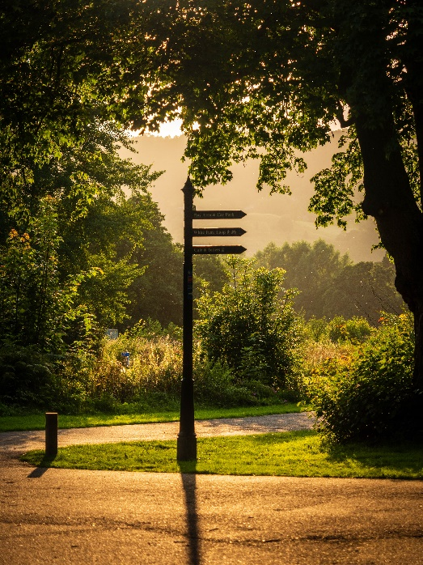
You will have learnt this by:
- exploring the practice of spiritual accompaniment
- exploring the relationships between personality, prayer, Christian growth and development
- learning how to apply the insights above to the lives of others
- Deepening your skills of listening and discernment
Cost of course
£385 (including the 2- night retreat cost)
Discretionary grants are available and open to all applicants. Local churches, deaneries, circuits and denominational bodies might be able to support too. Licensed Anglican clergy may use their CME grant of £250 towards the cost.
There are various ways payment can be made once you have been accepted on to the course, unfortunately fees will not be refundable if you drop out:
- £385 Lump sum up front
- Monthly standing order over 7 months (£55 a month)
- £200 in January and £185 in April
Venue
Darley Dale Methodist, Dale Road North, Darley Dale, Matlock, DE4 2FS.
This is on the A6 and buses running between Matlock and Bakewell pass it. There is plenty of green space for reflection around the church and in the adjoining Whitworth Park (pictured) and the journey to and from it from every direction passes through some beautiful idyllic Derbyshire countryside.

How to apply
For queries and to request an application form please contact:
Nicky Fenton 0781957913 nicky.fenton@derby.anglican.org
Closing date for applications is November 15th 2019 and interviews for all applicants will take place the first week in December.
The Art of Spiritual Accompaniment

Does your heart long for a little time and space to pray, reflect and consider what God might be wanting to say to you?
Do you find people open up to you and want to share something of their faith journey, prayer life and spiritual walk with you?

If the answer to those questions is YES then you might want to turn over and consider joining a small group of people exploring the art of spiritual discernment, direction and accompaniment together.

