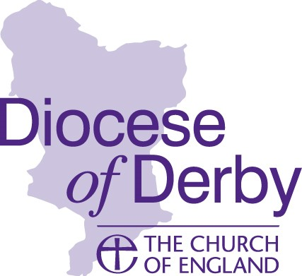

DERBY DIOCESAN BOARD OF FINANCE
Raymond Ross Fund – Small Grants

A portion of the established Raymond Ross fund is now being made available to parishes to quickly complete smaller mission focussed capital projects; for example, these might relate to accessibility, welcome, small-scale redevelopment of internal spaces etc.
In common with the Large Grant Scheme, your project needs to generate outcomes which achieve and support mission, community or growth.
The maximum grant available will be £5,000 and does not need to be match funded. Parishes will be required to take up grants within 12 months of a successful application.
Applications will be assessed by the Business Committee on a monthly basis.

CRITERIA FOR SMALL GRANTS
You should ensure that your application meets as many of the following conditions as possible:
- Imaginative schemes with full PCC support
- Church premises with strategic, long term future
- Single capital projects, not routine repairs or salaries
- Churches with minimal existing resources and reserves
- Support of the Deanery Synod Standing Committee
- Commitment to contribute toward the Common Fund
- Full disclosure of all parish accounts
- Compliance with Faculty Jurisdiction, disability legislation etc. where applicable
- Mission of the church in the community articulated by the PCC
- Only one application per church

APPLICATION FORMS, ADVICE, CONTACT NUMBERS

Completed applications should be addressed to:

Raymond Ross Fund
Mission & Ministry Team,
Derby Church House,
1 Full Street,
Derby, DE1 3DR

Or emailed to gareth.greenwood@derby.anglican.org

Applications will only be considered with authorising signatures and accompanied by full supporting documentation.

Further assistance can be sought from Gareth Greenwood, Community Project Development Officer, who will also gladly advise parishes at an early stage of developing project plans, to include community engagement and at later stages with regard funding possibilities.

Email: gareth.greenwood@derby.anglican.org Tel: 01332 388690

