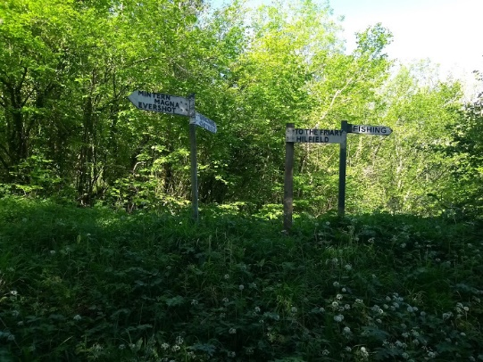
21st Century Franciscans: Caring for Creation
As I am writing this, I am looking out of my study window onto a wet, wet world. We have just experienced the worst flooding in our city and county in living memory, with devastating and tragic consequences. A month’s worth of rain fell in a single day, and whilst we can’t definitively attribute this to climate change, it definitely looks suspicious.
We only have to turn on the news on the television, open a newspaper or browse our iPad to be reminded daily that our planet is in trouble. Rising sea levels, melting ice caps, extremes of weather, forest fires, drought, extinction of species can all be laid at the door of climate change. And despite what certain world leaders may say, this is scientific fact and the flat-earthers can argue all they like, but they cannot escape the painful truth.
And so, a group of us gathered at the West Indian Community Association in Derby on a wet and cold October evening to hear about a different way of living.
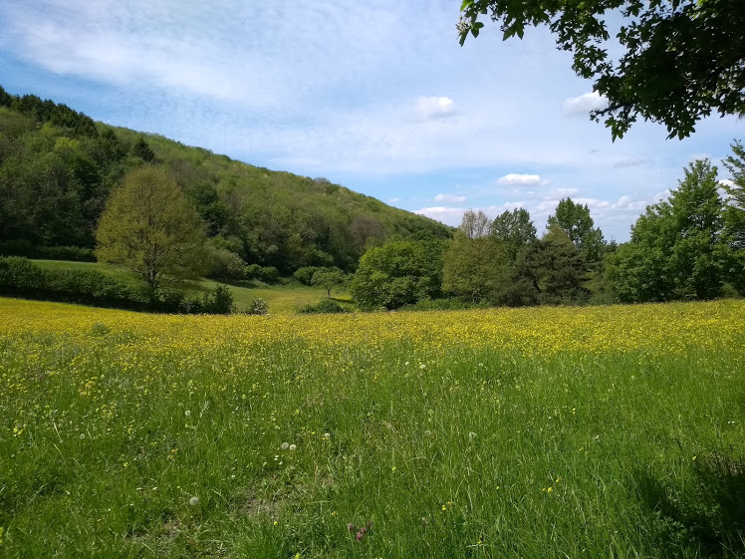
This event was organised by the Derbyshire Churches Environment Network who had invited Brother Hugh from Hilfield Friary to talk about his Franciscan community. It was both heartening and motivating. And whilst we can’t all aspire to run our households in such an ecologically wise way, we can all make changes.
The Hilfield community number about 25, an eclectic mix of Franciscan brothers, couples with children and single people. Their community statement is:
To seek to live simply and gratefully, caring for the Friary land that we have been entrusted with.
Following Christ in the way of St Francis we care for the poor & marginalized of our society and all of creation.
An open and inclusive community that welcomes all people and creation.

Brother Hugh then told us about the three Franciscan themes of social justice, poverty and work on behalf of creation, inviting us to sing the first verse of ‘All creatures of our God and King’ – the Canticle of the Creatures by St Francis himself. He linked these Franciscan themes by speaking about how the refugee crisis is largely climate driven. And he gave a colourful account of leading prayers on Lambeth Bridge as part of the Extinction Rebellion protests – even if The Sun newspaper branded him erroneously as a Buddhist!
He then invited us to think creatively. How can we reimagine Christian art, music, liturgy, hymnody in the face of the threats to our very existence? He mentioned the example of the Christian festival ‘Greenbelt’ which uses the phrase ‘Arts and activism – can we have one without the other?’ To illustrate this point, we sang ‘All things bright and beautiful’ to very different words – words of protest and change.
Finally, Brother Hugh asked the question ‘Is the climate crisis giving world faiths a common task?’ Let’s hope that it is, because whatever differences of faith we may have, we share one common purpose – that of being human and preserving our home.
The evening ended with a lively discussion around the issues raised by Brother Hugh before we ventured out into the damp evening, scurrying (guiltily in my case) back to our petrol-driven cars.
But, I reminded myself, the important thing is not to weigh ourselves down with guilt for what we are not able to change immediately. In our house, we are starting with what we can – recycling, taking the bus, turning the heating down. We are ever mindful of the need to be gentle with the earth and gentle with ourselves. Let’s spread the word as Christians, as people who love God and love the planet he entrusted to us, to make those changes where and when we can.
And the final word of the evening was ‘Do your best’. It’s all anyone asks.

Eirene Palmer
Inspired by an evening with Brother Hugh of Hilfield Friary on 24th October 2019
Pictures: top right from a walk on the periphery of the Friary, left Whiteways.

